**Bachelor of Software Engineering**

**Center for IT Education (CITES)**

**Department of Electrical and Computer Engineering**

**The Open University of Sri Lanka**

**EEI3346 – Web Application Development**

**Mini Project**

**Student Number (S92064060)**

**Student Name (MNM. SAFRAN)**

**TABLE OF CONTENTS**

Table of Contents

**AKNOWLEDGEMENT** 3

**INTRODUCTION** 4

**PROBLEMS FACED** 5

**Architectural diagram of the system** 8

**Site Map** 9

**Used Web Technologies and Examples** 10

**Tested Results** 11

**Conclusion** 16

# **AKNOWLEDGEMENT**

In performing my Mini Project, I had to take the help and guidelines of Open University of Sri Lanka course materials. who deserve my greatest gratitude. I would like to appreciate the immense patience shown by my parents while I was working on this. Also, I would like to thank them for supporting me wholeheartedly and providing me with everything I ask them for. I would also like to expand my deepest gratitude to all those who have directly and indirectly guided me in Working on this Mini Project. Many people, especially my classmates have made valuable comments, suggestions on this Mini Project which gave me the inspiration to improve my Mini Project. I thank all the people for their help directly and indirectly to complete my module case study

# **INTRODUCTION**

The contents of this Mini Project were carefully designed and include maximum details on it. This Project describes the scenario in the context of the events, news, images, videos and the all idea on it.

I put my full effort with in my working background. This Project will provide an in-depth analysis of the webpages about Pearl of Indian Ocean, Tourist information in sri lanka and I hope it will useful to the users.

This analysis had help to identify several vibes alternative to me for resolving the issues being experienced.

In this Mini Project I worked hard to creating the Web pages, I much plan step by step to do this, I wish it will satisfy the user who will use it. But any way I give my full effort with my working background to do this Mini project.

For this Mini Project I prepared well for the field were asked in the question and tried to do all those with my full effort. This is a good opportunity to my study too.

And the most important think about this Mini Project, I faced some issues during this Mini Project I give my full effort to solve that problem but some of that I can’t solve it because of my system, I am using a low system because of that I can’t install the vue js also think this is the I faced some issue on this vue js

For that pls consider it and forgive me.

I wish to thank you for giving me this opportunity.

# **PROBLEMS FACED**

1. I Faced some issue in creating to-do-list, I tried more but I can’t solve it because I can’t find what’s the error

I think this is a error because of not installing **vue js** in my system. Because of low running system

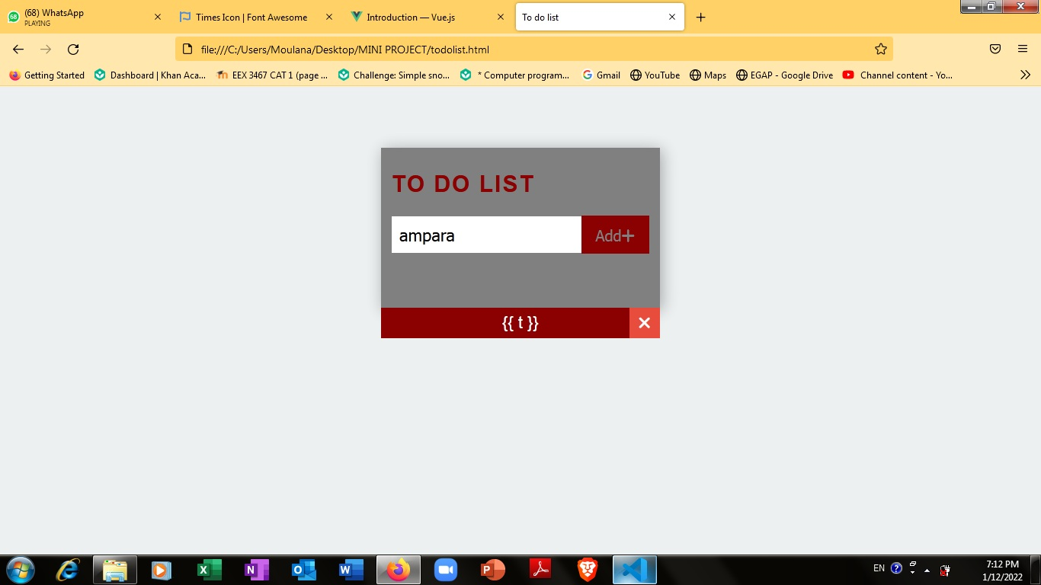

1. I faced some error in photo gallery.

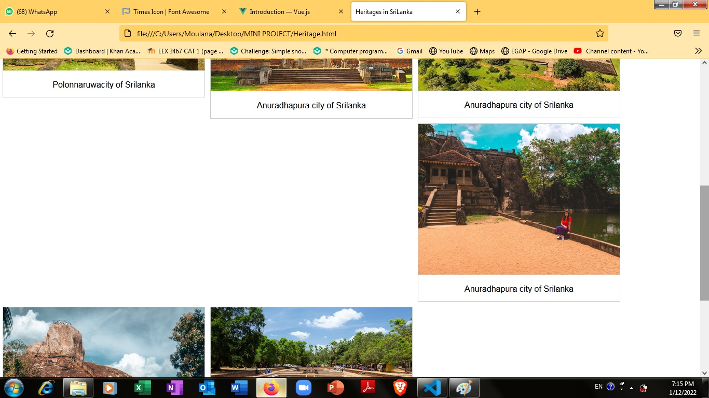

1. I faced some problem in font awesome bullet showing

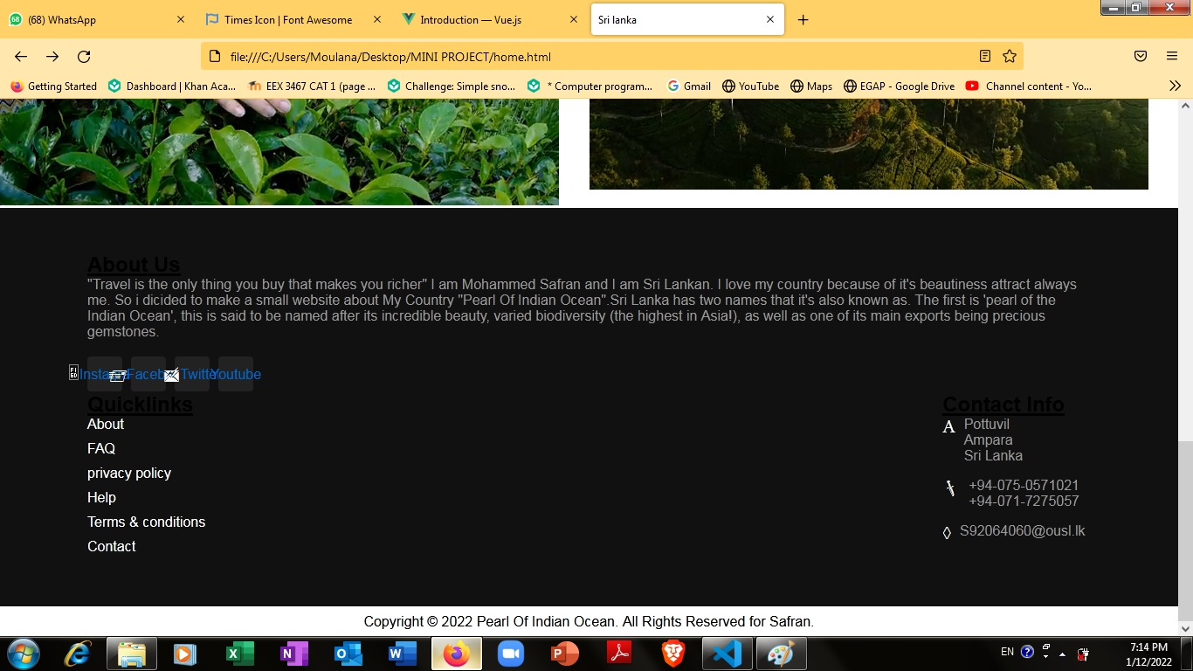

## **Architectural diagram of the system**

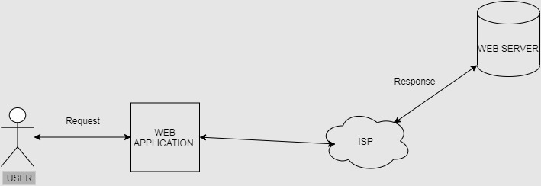

## **Site Map**

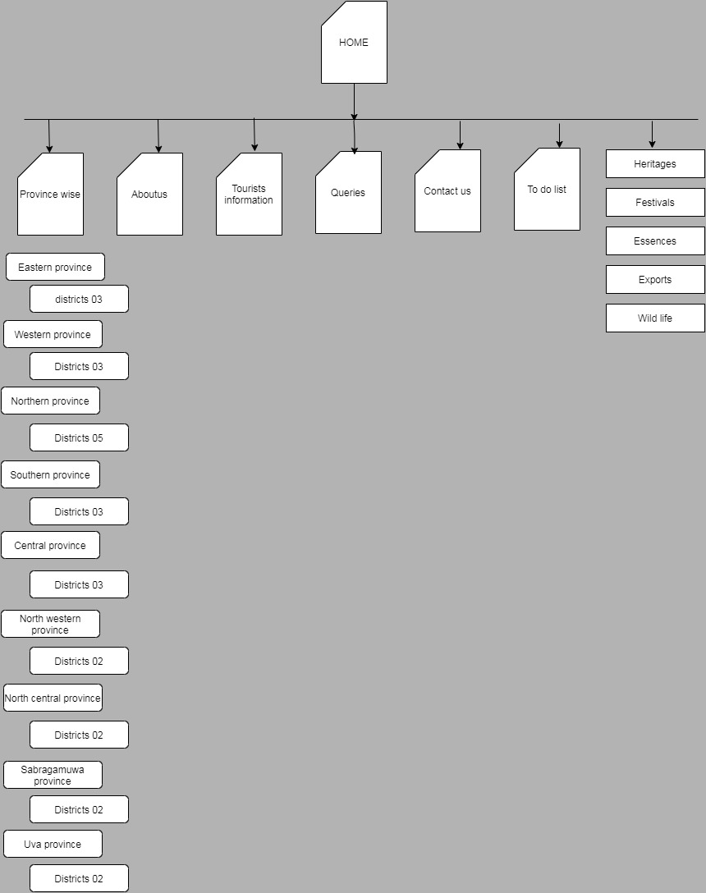

# **Used Web Technologies and Examples**

1. Open university Course Material
2. <https://vuejs.org/v2/guide/#Getting-Started>
3. <https://fontawesome.com/v5.15/icons/times?style=solid>
4. <https://en.wikipedia.org/wiki/Sri_Lanka>
5. Google pics.
6. <https://www.w3schools.com/js/>

**Tested Results**

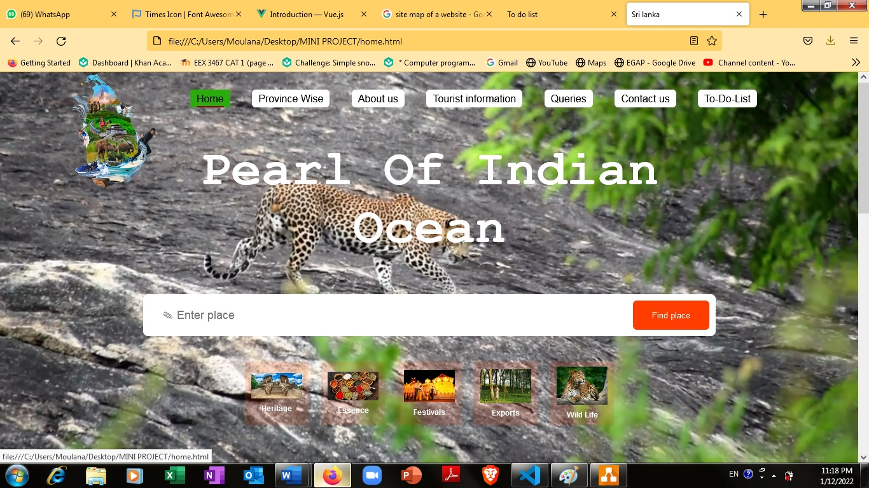

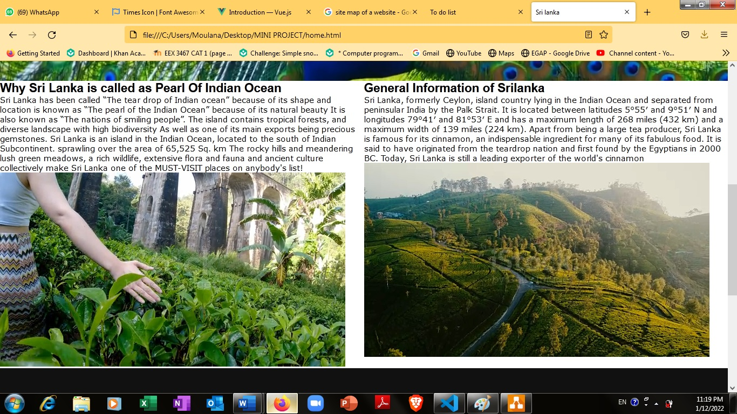

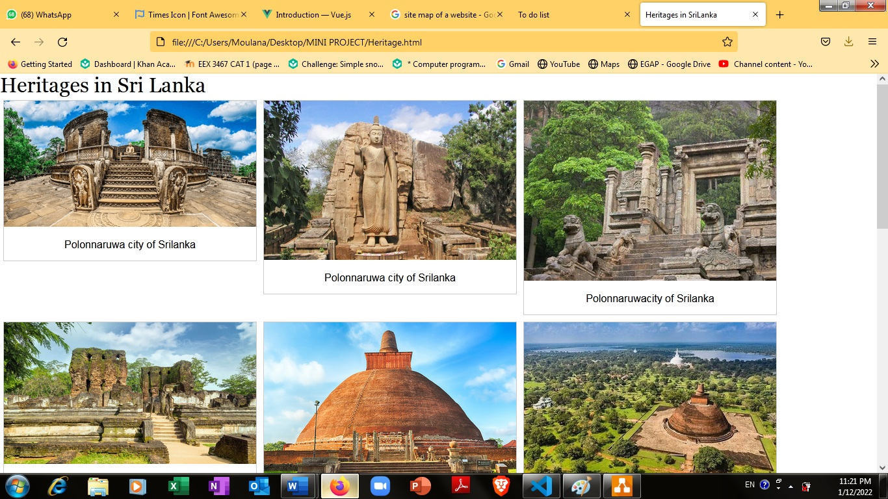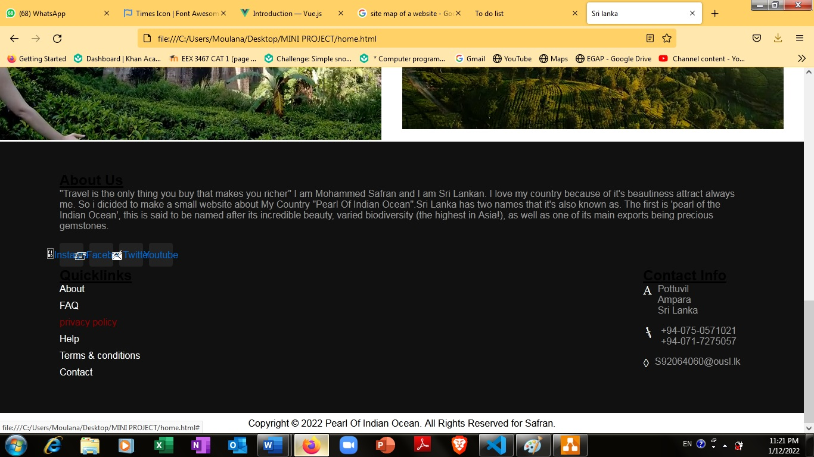

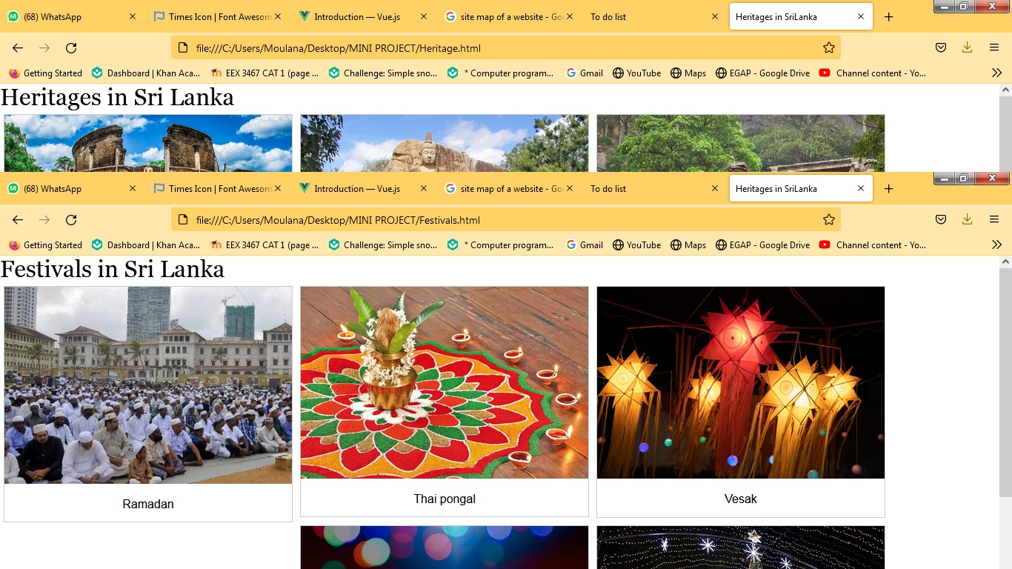

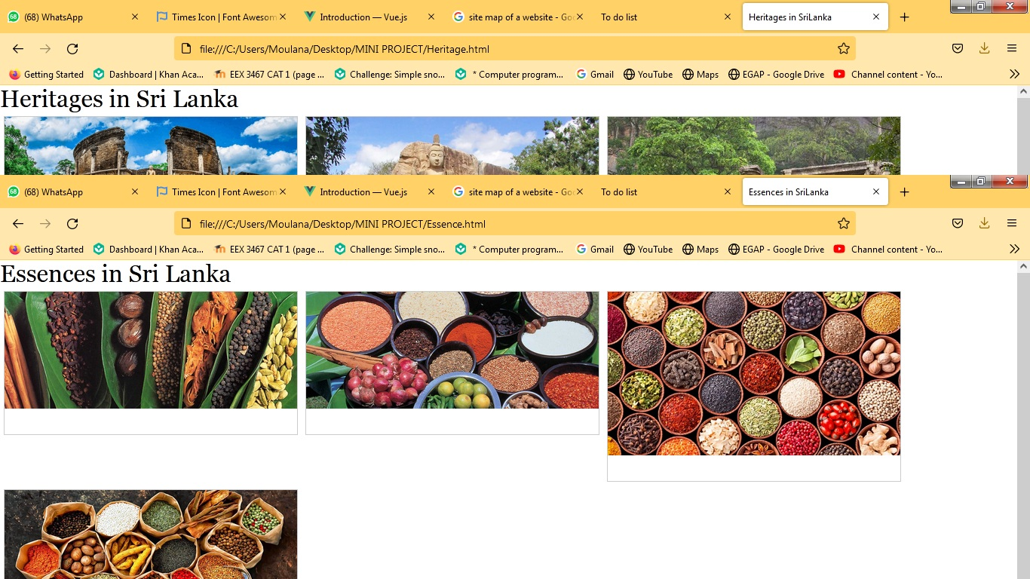

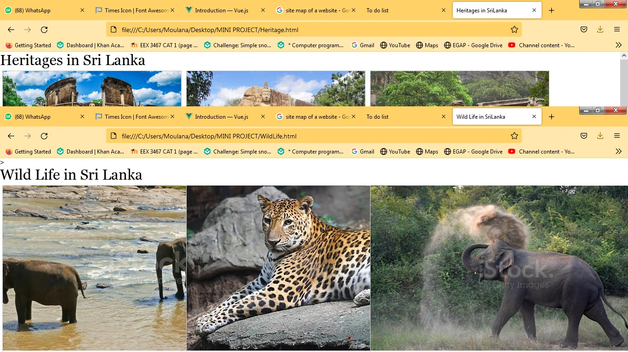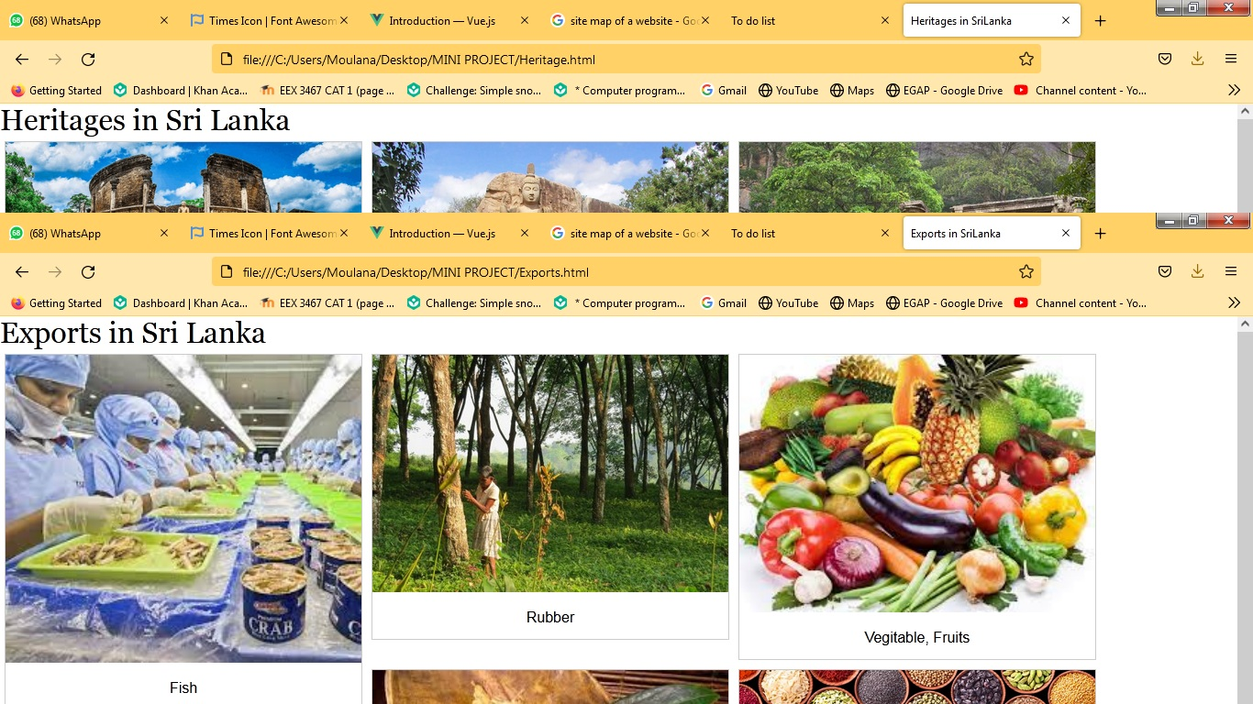

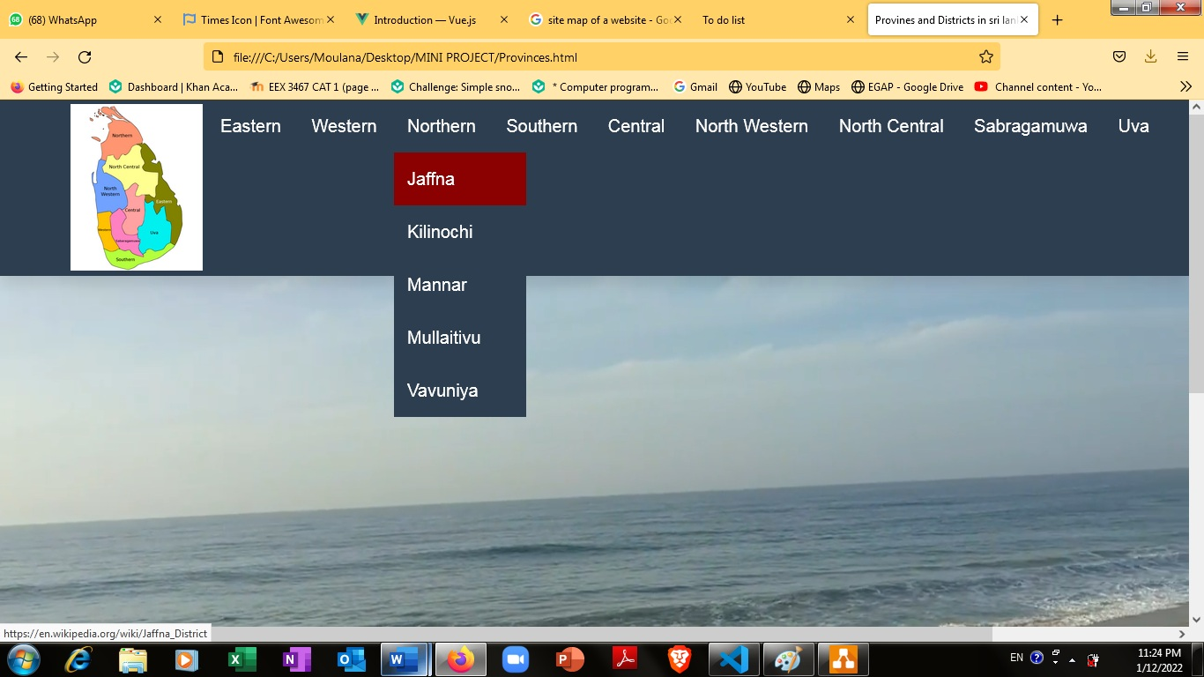



# **Conclusion**

Mini project is a valuable method of research with distinctive characteristics that make it ideal for many types of Investigation. It can also be used in combination with conclusion other methods. It’s uses and reliability should make it a more widely used methodology,

In this Project I put my full effort to do this case study, I surely tell this is my own knowledge and I didn’t copy any other or from any other resources. Please ensure my faults and give me the suggetions

I got good knowledge about Web page development from this Assessment

Thank you so much

Respectively,

MN. MOHAMMED SAFRAN

S92064060